**Tema**: astronomia

**Cores**: <https://coolors.co/0f021b-310165-310f57-3c1862-50168d>

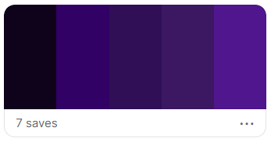

**Stack:**

React + TypeScript + Node.js + Styled Components